When Accessing the Tool, below are the issue(s) that can encounter and below are the steps to resolve them.

**Issue-1**

**Question**: When you encounter below Error, after opening tool and in Popup below message displayed.

“[Microsoft][ODBC Driver Manager] Data source name not found and no default driver specified”

**Possible Solution** :

Issue could have happened because of non-availability of software “Microsoft Access database engine 2010 (English)”. Please check for below software in Control panel 🡪 Programs and features.

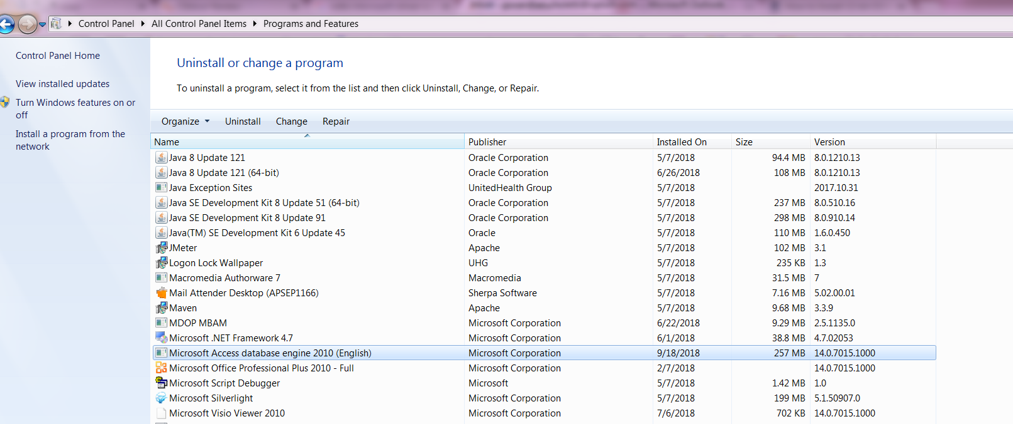

It the software is already present, but still issue persists. Perform either Repair / change of software, Perform Right click on software name to see those options as below :

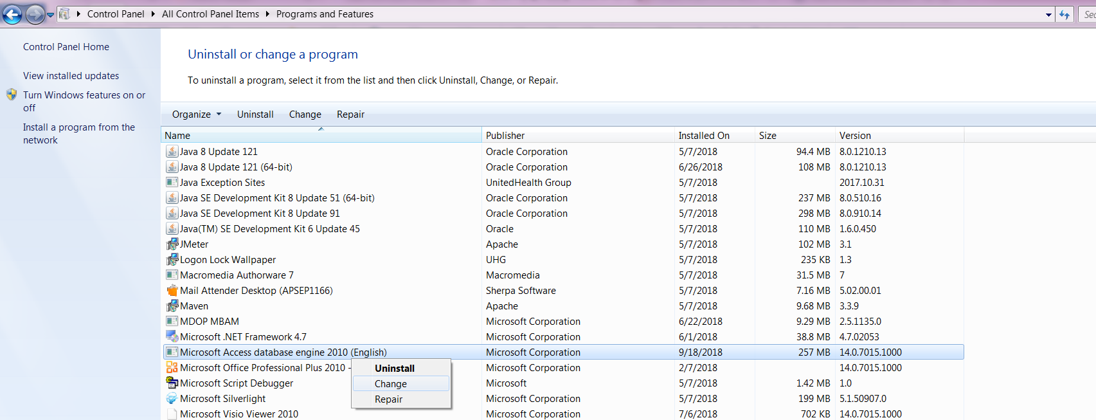

While repair/ change option is being performed. Make sure to close all the other applications i.e., Excel, Word, Folders, Sql Developer..

If Software is not present, get the software installed from official Microsoft page-<https://www.microsoft.com/en-US/download/details.aspx?id=13255>

Detailed Installation Instructions can be found in - <http://help.loftware.com/pages/viewpage.action?pageId=27099554>

**Reason for Failure:**

In Control Panel 🡪Administrative Tools as below :

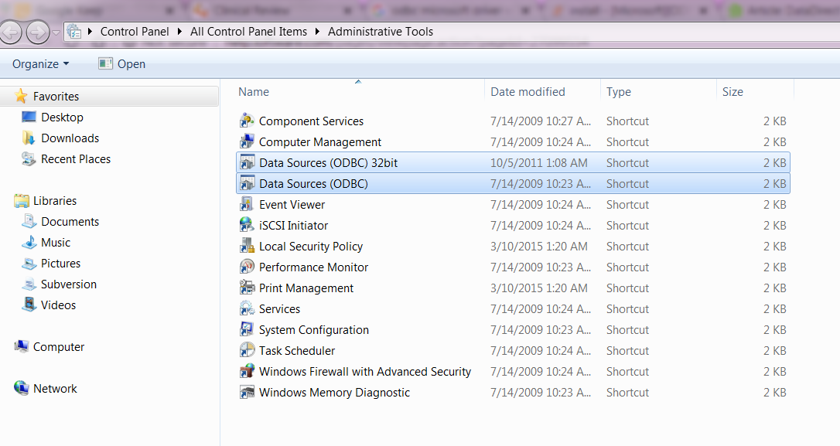

Required configuration in Data sources are missing or corrupted.

